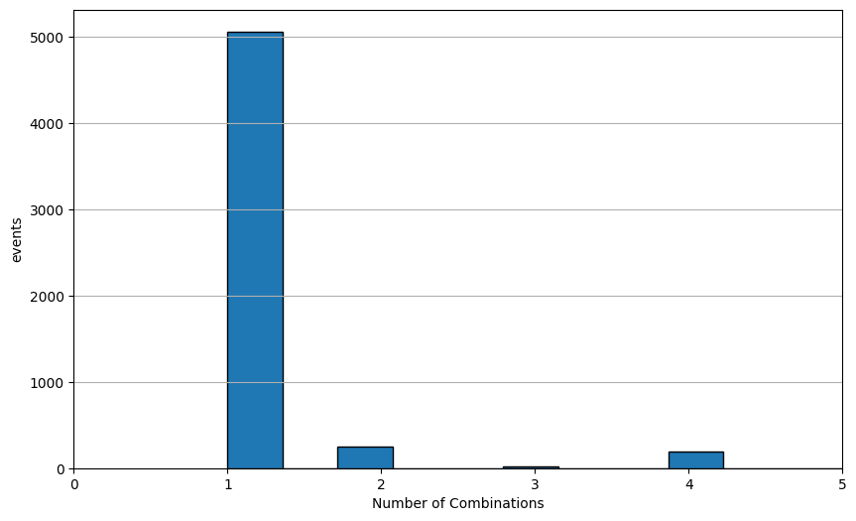

TDC 0 is not doing so hot in terms of timing corruption

WTF is this inconsistency. Could it because of the beginning is too much to offset the histogram??

Against a functional one

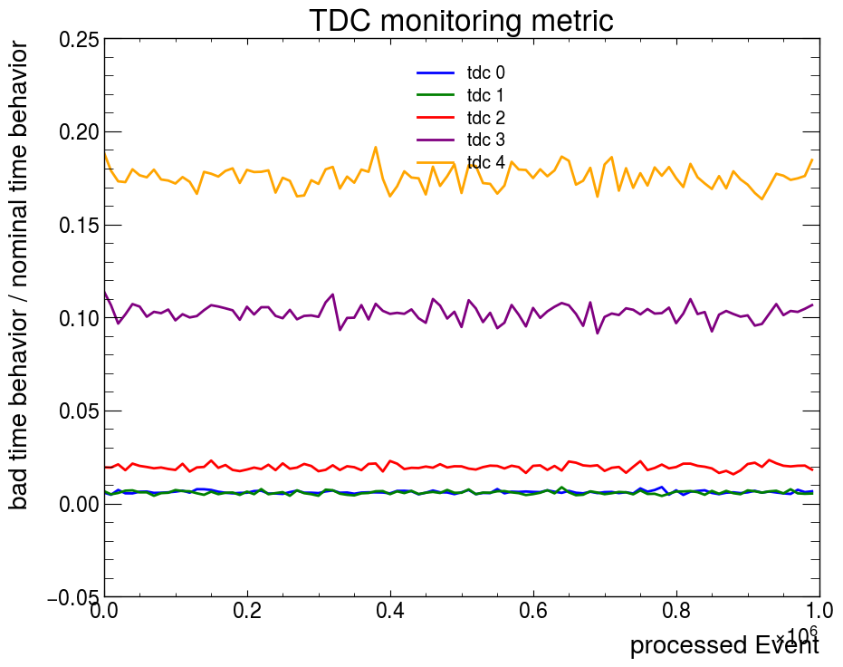

Overflow caused slightly higher metric

It seems like killing it makes the world a better place

\

Latest fit

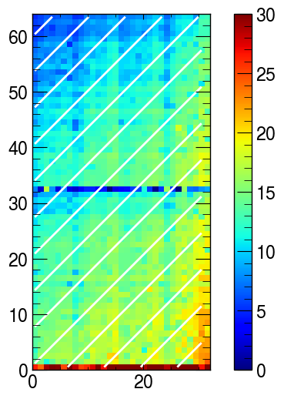

0.15204446322001586 16.101626655986728

R² value: 0.5449375100842333

Using a previously proven better one

0.2414729993270939 17.80237203117277

R² value: 0.8482098999124904

This is the shit looking residual

Time walk effect definitely not correctly corrected.

Back to the basics. Lets remove all Corrections

Eta and phi correction logic wrong, correct for phi time using eta strip Is the way you mother fucker. Then look at angles